Project 7: Mesh of Springs

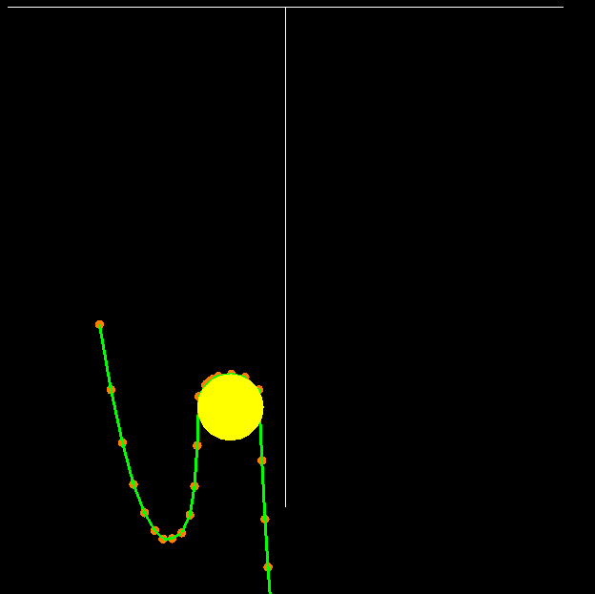

My computer was going a bit slow, so I kept resetting to show the components individually, but I believe that it is all working correctly when running together.

Video Link: <https://media.oregonstate.edu/media/t/0_gloae8ro>